|  |
| --- |
| TEXT summarizer  Using NLTK and Deep Learning |
| AkankshaAditya |

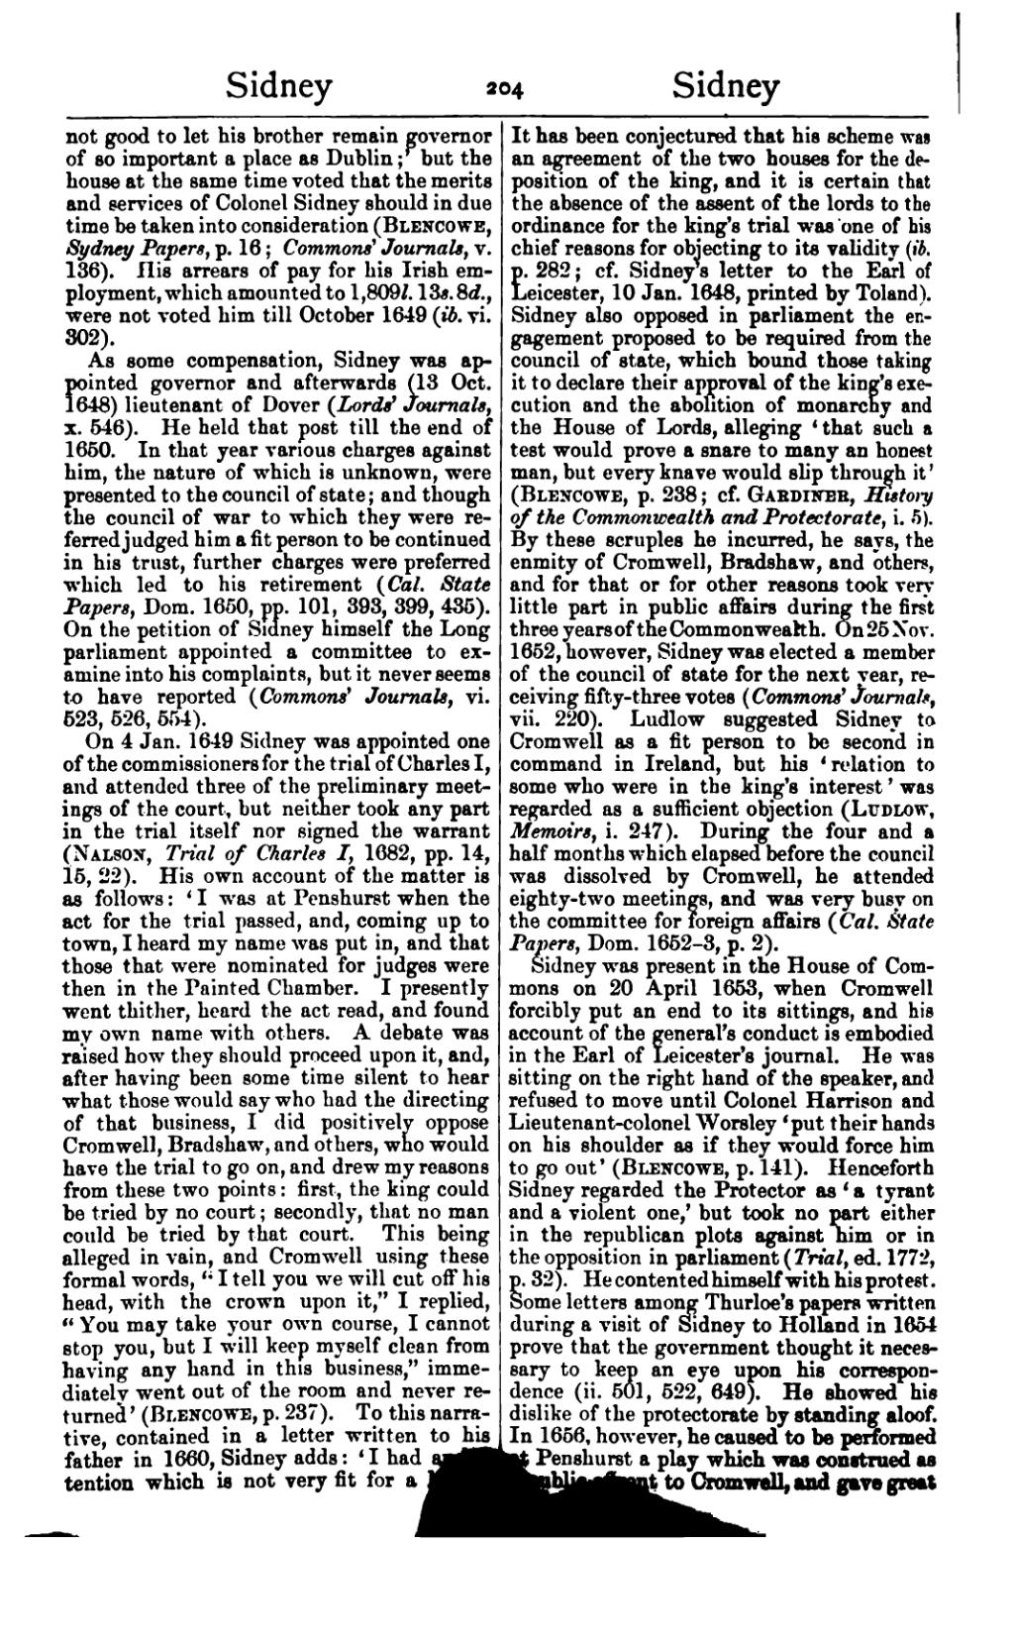

## Project Abstract

### Problem Definition:

Design a software to summarize a piece of text and summarize into a meaningful summary of few lines, which is within logically acceptable limit along with its genre.

#### features of the application:

The project is a desktop application based on Python-Tkinter UI framework. The user is supposed to input a text, for example, the input could be a small paragraph, long essay, and article. It might be cut pasted text from Wikipedia, image processed text, handwritten text image or web-scraped text material. Irrespective of the type of text, the software would take the input, process it down and output the synopsis of the input (length in accordance to the input length) and its genre.

As a small addition to make the software UI interactive, the ongoing processing activity would be accompanied by Matplotlib-graphs as a roll on.

PROCESS MODEL EMPLOYED:

The process employed here is Rapid Application Development Model. We wanted to employ this model because of the project’s job segregation.

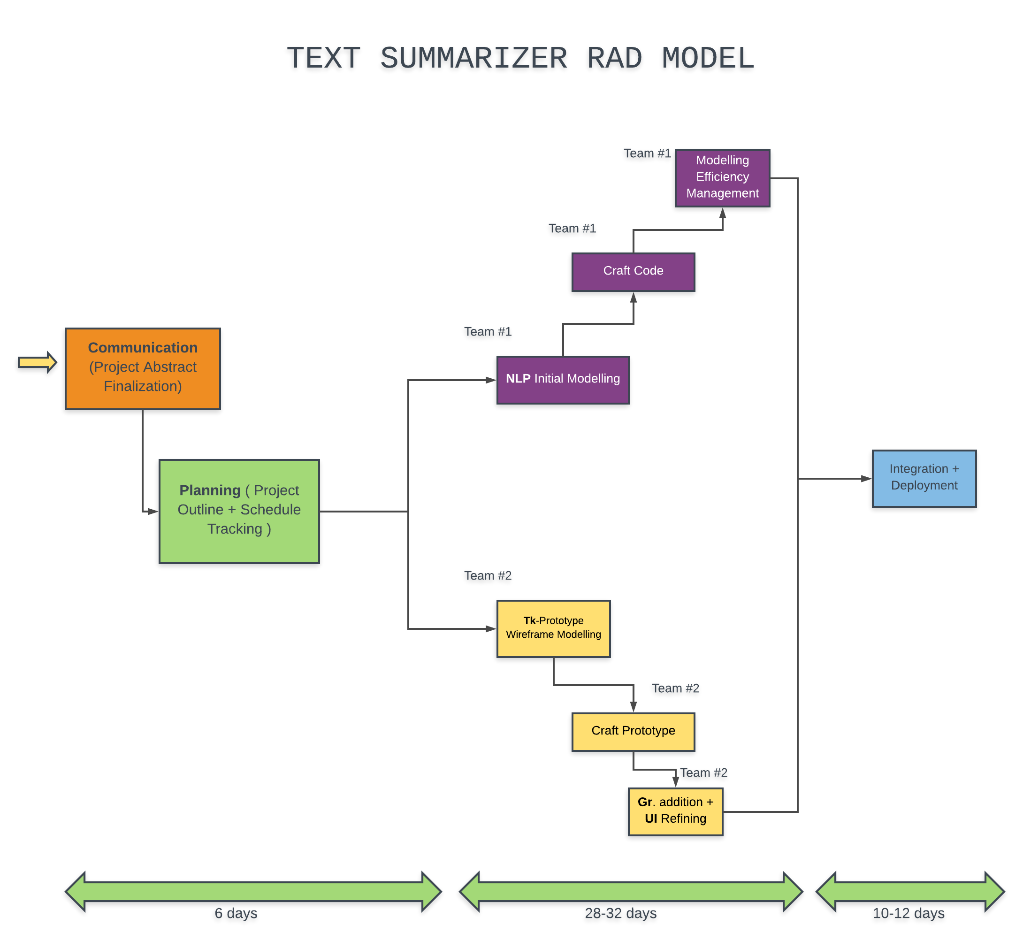

As it can be seen here, the development phases on the entirety of UI/UX and logical backend are independent.

So, employing this model was more rational and sensible and the others.

**Timeline:**